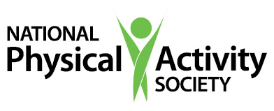

Continuing Education Certificate

_____________________________________
Participant Name
has earned 1 CEC by attending

Two Documents, Explained
Presenters: Amy Eyler, PhD, CHES, and Kevin Roth, PhD
Webinar: April 16, 2018

