National Physical Activity Society
Continuing Education Certificate

_____________________________________
Participant Name
Has earned 1.0 CECs by attending
5 Things to STOP Doing if You Want to Boost Physical Activity in Your Community (presenter Mark Fenton)
Webinar: February 8, 2016
Pam Eidson
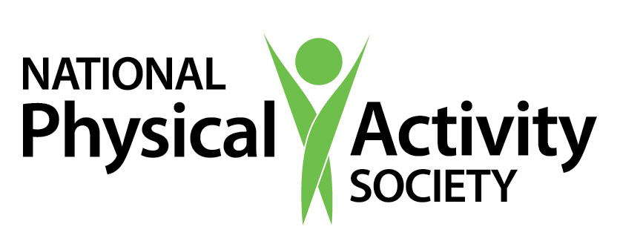
Lead Program Administrator

NPAS/ACSM Approved Provider Number for PAPHS: 656528
Pam Eidson, MEd, PAPHS
Executive Director

